**PLATE BOUNDARIES**

[**Divergent boundaries**](http://www.cotf.edu/ete/modules/msese/earthsysflr/plates3.html)

1. [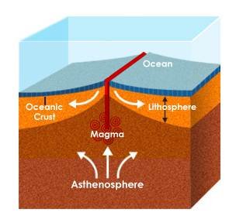](http://www.absorblearning.com/media/attachment.action?quick=12n&att=2771)Divergent boundaries occur when two plates move apart from one another.
2. As the plates move apart, molten rock from the asthenosphere rises and fills the gap between the plates.
3. The molten rock then cools and becomes new crust. The locations of these spreading boundaries are usually found on the ocean floor and result in the formation of a ridge.

[**Convergent Plate Boundaries**](http://www.cotf.edu/ete/modules/msese/earthsysflr/plates2.html)

1. [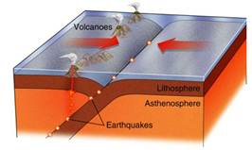](http://www.absorblearning.com/media/attachment.action?quick=12s&att=2781)Places where plates crash together are called convergent boundaries.
2. Plates only move a few centimetres each year, so impacts are very slow and last millions of years.
3. For example, in the drawing, an oceanic plate on the right has crashed into a continental plate on the left.
4. The edge of the oceanic plate has bent down and dug deep into the earth
5. A trench has formed at the bend.
6. All that pressure and bending makes rock in both plates break and melt, causing a trench.
7. As the edge of the oceanic plate digs into Earth's hot interior, some of the rock in it melts.
8. The melted rock rises up through the continental plate, causing more pressure on its way up, and forming volcanic eruptions where it finally reaches the surface.

**Transform Plate Boundaries**

1. [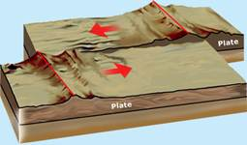](http://www.seed.slb.com/flash/science/features/earth/livingplanet/plate_boundaries/en/index.html?width=570&height=475&popup=true)When two plates slide past each other a transform fault boundary is formed.
2. The plate edges do not slide past; instead they grind past each other in dramatic, quick movements which result in earthquakes.
3. The San Andreas fault is an example of a transform boundary